Everything You Should Know About HDI PCBs

Section1. Introduction
HDI PCB is one of the latest technologies that combine mini bind and buried hole, a high-density distribution circuit board. In most cases, HDI is designed mainly for small capacity consumers of compact products.
It is an informative guide on everything to do with HDI PCBs such as the difference between them and conventional PCBs, their advantages, how to go about choosing the right HDI PCB material, and some of the reasons as to why people need to embrace HDI technology among others.
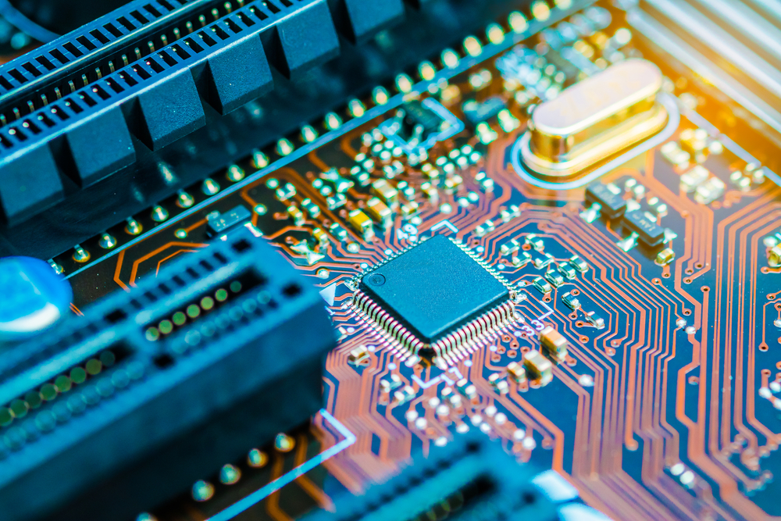
Figure1: An image of an HDI Printed Circuit Board

Section2. What is HDI PCB?
In detail, an HDI PCB is a unique kind of circuit board that consists of relatively high-density distribution that employs micro-blind technology. It consists of a plate (HDI plate) that has got an inner and outer line, which can be easily connected internally by metallization and drilling.
HDI PCBs take advantage of recent technologies that exist to amplify the operation of circuit boards using little amounts of area. The tininess of its parts motivates the development or progress in board technology in addition to semiconductor packages that help superior characteristics in products such as touch screen tabs.
HDI PCBs are described by its high-density features that comprise of laser micro-vias, fine lines, and high-performance thin components. Their better density gives room for extra functions as per the unit area.
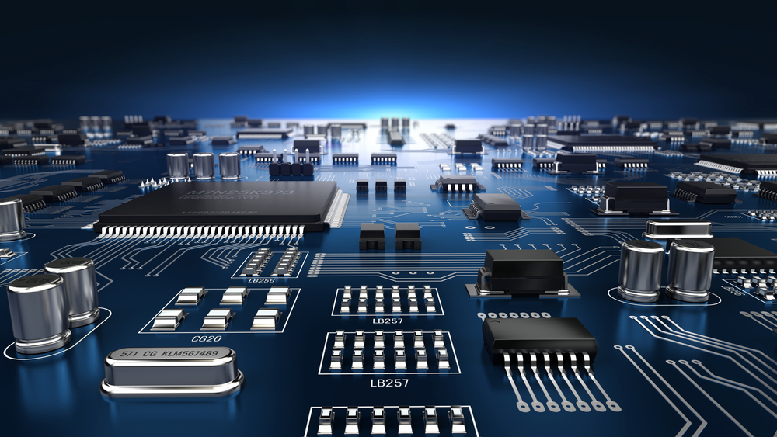
Figure2. An up-close shot of a board that uses HDI technology on its PCB

HDI PCB technology is one of the fastest growing technologies that was widely implemented, especially at the end of the 20th century. It is during this time that plenty of HDI PCBs became available in huge numbers. As of now, there are plenty of them in the market ready for use with hundreds of companies using them and plenty more thinking of embracing such a technology.
HDI PCBs are very appropriate for a wide range of uses and industries. You can easily find them in nearly all types of digital devices such as tablets, digital cameras, smartphones, and laptops where miniaturisation is crucial towards the effective operation of the product.

Section 3: What Are the Differences Between an Ordinary and HDI PCB?
There are striking differences between an ordinary PCB and an HDI PCB worth noting. HDI boards are commonly manufactured through a laminate method. The more times its layers are stacked, then the higher the boards’ technical grade.
Ordinary PCB boards are mainly one-time laminate while high-order HDI tends to use stacks of two layers or more of technology. HDI PCBs also adopts higher PCB technology such as plating holes, stacking holes, and direct laser drilling.
Unlike conventional or traditional PCBs, HDI PCBs are circuit boards that consist of a relatively high-density interconnection and line of distribution using a micro-blend hole. The HDI board has got both an inner line and an outer layer line and utilises a process such as metallization and drilling in the hole to connect the inside of every layer.
To put everything in the simplest terms possible, HDI PCBs are much more advanced and developed than ordinary or conventional PCBs. Despite their difference in circuit density, HDI PCBs and conventional PCBs differ in terms of their construction techniques and also between electrical performance and signal.
HDI PCBs use a more complicated technology that involves the stacking up of more than two layers while conventional PCBs only require a single layer of technology to function. On the other hand, HDI PCBs even get better based on their electrical performance and signal. Unlike conventional PCBs whose electrical performance and the signal may not be that impressive, HDI PCBs highly excel in terms of performance.

Section 4: What Are the Advantages of HDI PCBs?
There are plenty of reasons as to why a lot of people and companies utilise HDI PCBs. But why should HDI PCB be utilised? What are some of the advantages that accompany this type of technology? HDI boards have got many physical and technical advantages over conventional or standard surface boards such as:
- Size – based on sheer technical characteristics, HDI PCBs, have the capability of accommodating additional connections in the same size PCB for a denser printed circuit board, and with a lower number of layers.
- Reliable performance and stable power – HDI PCBs offer greater reliability than traditional PCBs. The level of superior reliability offered by small-bind vias over such PCBs through-hole based on the greatly reduced aspect ratio is undeniably great.
- Design advantage – HDI PCBs offer the designer with increased flexibility based on the increased capacity on the board that brings about faster signal processing.
- Functionality – with HDI PCBs, multiple traditional PCBs have the capability of being integrated into one HDI PCB.
- Signal integrity – HDI PCB technology also promises improved electrical performance coupled with higher signal integrity requirements.
- Denser trace routing – HDI PCBs are known for increasing density of interconnection by reducing pad size, plated through holes, and conductor size reduction.
- Improve signal integrity in high-speed design – HDI technology boasts of better technology performance coupled with signal validity.

Section 5: Why You Should Use HDI Technology
For almost the entire applications that pertain to aeronautics, computers, consumer products, and electronics, HDI PCBs are not only suitable but also favoured. Even in some of the most intense settings, HDI PCBs consisting of multiple layers have continued to supply increased levels of reliability based on their robust interconnection that involve stacked vias.
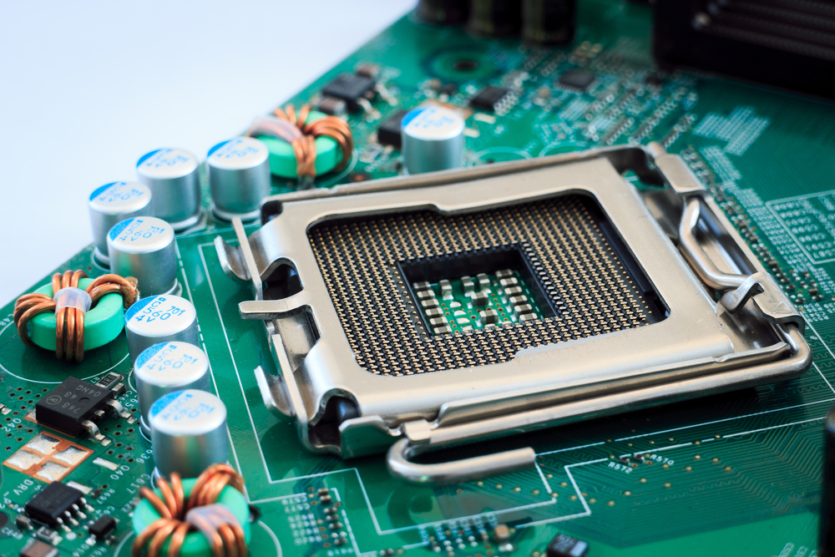
Figure3. An image of a device’s motherboard that infuses the HDI technology
But why is HDI technology necessary? Why should you or the company that you currently work for use HDI technology? There are plenty of reasons as to why HDI technology should be embraced or used by people and manufacturers.
Based on their reliable performance, lightweight, and strikingly small size, HDI PCBs are technically appealing for mobile, wearable, and handheld electronics. On top of the geometry of the high-density design, these smaller but stronger components elevate the functioning of a PCB in addition to the end product that puts it into use.
With components getting close to each other, electrical signals require less time to travel. However, the high-density of HDI PCBs minimises the rise time for inductance and the signal, thereby reducing the effects on nearby leads and pins. Additional transistors work not only by supporting increased functionality but also heightens matters concerning performance.
By heavily concentrating on HDI design, the time and cost of cultivating prototypes become relatively short. Also, shortened delivery time can increase the profit margin. In short, HDI comes with several advantages in areas of package size, performance, and overall weight.

Section 6: How to Choose HDI PCB Material
Choosing the desired PCB material is very crucial regardless of the type of application that you are using. However, the stakes get even much higher with HDI technologies since they are small, sturdy, very light, and require specific connection requirements.
When you decide on using solder that is lead-free, then choose materials whose decomposition temperatures are high and are somewhat of better quality. Which criteria should use when selecting the right materials for your HDI PCB?

HDI Stackup: What does it involve?
Before proceeding, it’s necessary to understand what HDI Stackups involve as such matters based on the materials that will go to the HDI PCB. On the issues that pertain HDI Stackups, resin matrix works by providing the resistance and dielectric properties that separate some of the most conductive layers such as copper foil.
Picking the correct resin or dielectric material is crucial for HDI best performance. In most cases, they tend to be of high quality when compared to conventional multilayer PCB materials, which should have the following traits:
- Decomposition temperature
- Temperature transition of the glass (Tg)
- Delamination time
- Thermal expansion coefficient on the Z axis
In most cases, the cost of the materials is directly proportionate with their performance. However, depending on the type of your application, you may have to go for materials suitable for that. We have four different categories of materials ideal for HDIs,
- Medium speed & loss: these top among the most available PCB materials of the family FR-4. The materials’ frequency response versus the dielectric constant isn’t completely flat and has a much more dielectric loss.
- High-speed & low loss& high signal integrity: When it comes to these materials, they have a low dielectric loss and a flatter dielectric constant as compared to the frequency response curves.
- Rapid and low loss: With such speeds, High-speed materials are also used in HDI PCBs, and the good thing about them is that such materials have got flatter dielectric constant versus the frequency response curve. They also have a dielectric loss that is about half that for medium speed components.
- RF, microwave, High-speed, low loss with high signal integrity: components for making Microwave/RF applications tend to have small dielectric losses as well as the flattest dielectric constant in comparison to the frequency response.
For microwave materials, consider using components with the least dissipation factor.

Section 7: Why OurPCB Is the Right Manufacturer for Your PCB needs
Are you in the market for a professional HDI PCB manufacturer for high-volume production and prototyping to work within the globe? If so, look no further than OurPCB. With more than a decade in the field, we have always been committed to meeting the needs of our customers from a wide range of industries in terms of delivery, quality, and cost-effectiveness among many other demanding requests.
As one of the most experienced HDI PCB manufacturers in China, we take pride in being your experienced business partner as well as your best friend in every aspect of your HDI PCB needs. With us, expect on-time shipping, transparent pricing, social responsibility, reliable quality, a dedicated customer service, and an efficient online instant quoting.
In the manufacture of PCBs, especially HDI PCBs, a cable harness firm whose function is to handle cable and wiring assembly is necessary to save time and extra costs associated with outsourcing such services.
Our OurPCB has a wire harness subsidiary called Cloom that handles electronic harnesses, signal wires, and automotive wiring harnesses. Cloom Cable is one of the largest suppliers of wire harness assemblies and custom cable, with the capability of transforming any idea or design into a practical harness to fit the needs of clients.
Conclusion
Globally, there seems to be a sharp demand for HDI PCBs, especially by manufacturers who find them necessary towards the manufacture of electronic components. As mentioned earlier, HDI PCBs have got more than a dozen benefits, a reason as to why their usage is increasing on almost a daily basis, unlike conventional or traditional PCBs. While careful consideration is necessary, especially when choosing the right materials to use, finding the ideal manufacturer is equally crucial. We at OurPCB meet all the criteria of the best HDI PCB manufacturer.

This article was added to EverythingPCB on August 8th, 2019

